CE2107 Lab4 Assignment Sheet (to be submitted to NTULearn before next lab)

Name: Unnikrishnan Malavika Lab Group: SEP4 Date: 19/10/2020

1. Section 6.1. What is the issue when an obstacle is place to close to the IR sensor? What can you do to prevent such ambiguity?

**ANS. As we can observe from the graph of sensor reading vs. distance, the curve isn’t monotonic. So the sensor reading has a sharp increase for distances close to the sensor and this continues until a threshold distance. This leads to an ambiguity because for the same y-axis value there’ll be two x-axis values. To prevent this, we must remember that the sensor can only give accurate measurements for values greater than or equal to the threshold. So, we ignore the part of the curve before the threshold.**

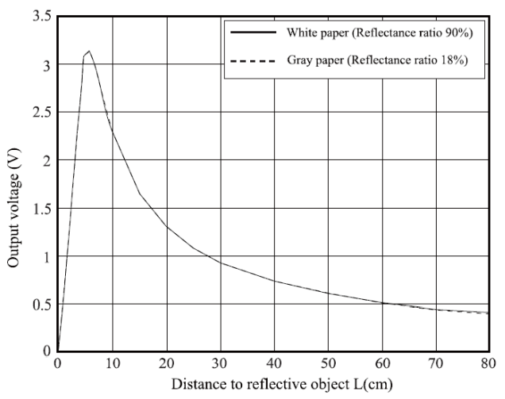

1. Section 6.1. What is the purpose of the 10uF decoupling capacitor?  
   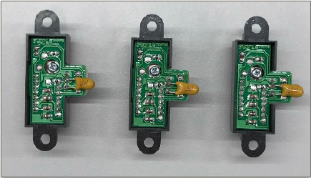

**ANS. The decoupling capacitor is used to reduce the noise on the voltage reading by the sensor.**

1. Section 6.2. Which port pins is ADC Ch12, 16 and 17 input mapped to? What is the PSELx settings required to configure the pins to ADC function?

**ANS. ADC Ch12 -> Port 4, pin 1 (P4.1)**

**ADC Ch16 -> Port 9, pin 1 (P9.1)**

**ADC Ch17 -> Port 9, pin 0 (P9.0)**

**PSEL settings for Port 9 ( both SEL0 and SEL1 for pin 0 and 1 of port 9 = 1)**

P9->SEL1 |= 0x03; // 8) analog mode on P9.0/A17 and P9.1/A16

P9->SEL0 |= 0x03;

**PSEL settings for Port 4 (Both SEL0 and SEL1 for pin 1 of port 4 to be = 1)**

P4->SEL1 |= 0x02; // 8) analog mode on P4.1/A12

P4->SEL0 |= 0x02;

1. Section 6.3. With respect to the ADC on MSP432, what are the two stages involved in every Analog to Digital Conversion of a Analog signal?

**ANS. MSP432 uses 14-bit SAR analog to digital converter. So the 2 stages are:**

1. **Sample and Hold stage**
2. **Actual ADC conversion by SAR**
3. Section 6.4. What does the function LPF_Calc() does? What are the initial values of the buffer associated with LPF_Calc()? Why do we need this function?

**ANS. LPF_Calc() takes ADC data as input and adds it into a LPF sum variable while simultaneously subtracting the oldest data in the circular queue( of Size = 256, which is stored with initial data (from LPF_Init() function)**

**Initial value of Size =256, LPFSum += newdata – x[I1]; where x is the queue.**

**We need this function because it removes all the high frequency noise from the reading we get from the tachometer.**

1. Section 6.4. Describe the algorithm you used to estimate the actual distance based on the IR Sensor value.

**ANS. So, the algorithm that I used makes use of graph fitting concept. I sampled 3 sensor values for each length from 1-30 cm ( ignoring 1-5 because 5 was the threshold). Then I plotted the graph of the equation $l=\frac{A}{nc-B}$ where for example, nc is center sensor reading.**

**So, this algorithm calculates the value of L based on this expression and returns it.**

1. Section 7.2. Which timer capture input (Timer and Channel number) does P8.2 and P10.4 correspond to?

**ANS. Both correspond to Timer A3 input.**

**P8.2 - capture channel 2 of Timer A3 (TA3CCI2A)**

**P10.4 - capture channel 0 of Timer A3 (TA3CCI0A)**

1. Section 7.2. Which edge (falling, rising, both) is the timer input capture configured to trigger on? What happens when a capture event occurs?

**ANS. The timer input is configured to capture on rising edge of the square wave pulse from the Tachometer. When a capture event occurs, the timer value at that moment (rising edge) will be saved to corresponding CCR register channels. This is done in the timer interrupt handlers TA3_0_IRQHandler and TA3_N_IRQHandler respectively which get called when interrupts from Timer A3, channel CCI0A and CCI2A are generated.**

**In the ISR, the two tasks PeriodMeasure0 and PeriodMeasure2 (corresponding to the CCI0A and CCI2A channels connecting to tachometer output) are executed. These tasks calculate the period between two rising edges of the tachometers.**

Section 7.2. Why is the calculated value of pulse duration, derived from the timer capture values, not a constant value but seemed to keep changing?

**ANS. Since the calculated value is based on the conversion of an analog signal to a digital square pulse, fluctuations in the analog readings will lead to a non-uniform square pulse.**

**For example, in the case of the tachometer, as the motor turns, the magnet turns and the changes in magnetic field is detected by the Hall effect sensors below the magnet and transduced into electrical voltages. These voltage values will vary (as the readings are taken continuously) and hence the ADC conversion will result in different values of pulse duration each time.**